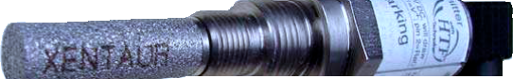Xentaur

Model HDT

Loop-powered
Hybrid Dewpoint Transmitter

-100°C(dp) to +20°C(dp)

• HTF™ Aluminum Oxide Sensor Technology

• Loop-powered (2-wire)

• Analog (4-20 mA) Output

• Digital (HART Compliant) Output

• Programmable Alarm Signal

• NEMA 4X IP66 Stainless Steel Enclosure

• Compact Design

• Temperature Compensated Calibration

• Certifications applied for: CE, IS(UL,Demko)

HDT Hybrid Dewpont Transmitter

HTF™ High Capacitance Aluminum Oxide Sensor The HDT uses a Xentaur HTF™ high capacitance alumi- num oxide sensor with a measuring range of -100°C(dp) to
+20°C(dp). HTF™ sensors provide a degree of accuracy,
speed of response and stability unavailable from instru- ments using conventional sensors.

Hart-compliant, IP66/NEMA4X Transmitter
The model HDT is a HART compliant IP66/NEMA4X hybrid dewpoint transmitter, providing loop powered analog as well as a digital output. Housed in a 1.25”dia. stainless steel
case it has an overall length of 5.68”, including the standard industrial 9.4mm 4 pin connector. This makes the HDT the world's smallest dewpoint transmitter.

Analog Output Loop
The instrument draws 4-20mA from the power supply. The
4-20mA is linear to °C(dp) with an output resolution of
0.1°C(dp) or 0.25uA, whichever is greater. The output range is programmable.

Digital Output Loop
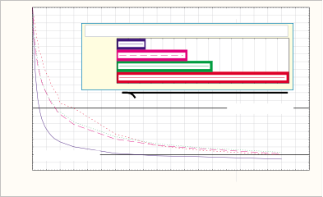The instrument can supply a digital output by modulating the 4-20mA loop line. The interface is defined by HART. In the digital mode the HDT can be remotely operated and the
dewpoint as well as temperature (and pressure if installed) can be read. In the digital mode multiple units can operate on the same loop cable as a multi-channel instrument. In this configuration each HDT draws only 4mA independent of the measured dewpoint

Built-in Alarm
The HDT provides a factory programmable dewpoint alarm signal through a digital output pin. Additionally, relays or external devices can be operated through the analog or digital loops.

Connections
The HDT has two different thread types, which makes the upgrade of existing installations easy. The HDT con- nects through inexpensive two-conductor cables over long
distances.

Measurement Accuracy/Stability
The HDT transmitter uses a multipoint calibration table which provides temperature compensated dewpoint read- ings for temperatures from -10°C(t) to +70°C(t). Thus, the HDT provides accurate dewpoint measurements over its full range even under extreme temperature conditions, such as when installed outdoors or close to heat sources.

Xentaur HTF™ Aluminum Oxide Technology
Due to a hyper-thin film and a unique pore geometry, Xentaur sensors have a capacitance change over their full range, several orders of magnitude larger than that of conventional aluminum oxide sensors. Additionally, this change is quasi linear and its sensitivity to temperature is negligible.

The advantages of the linear high capacitance response of Xentaur HTF™
sensors are shown in the graphs below:

Hyper-Thin-Film vs. Conventional Al2O3 Sensor
Deviation in °C(dp) from the measurement at 6.5 month
Change of Capacitance with Dewpoint

Negligible
Ageing Drift

1.5
1.0
0.5
0.0
-0.5
-1.0
-1.5

Aging effect on dewpoint measurement of sensor s/n 15730 over a 6.5 month period, exposed to -85°C(dp) at +60°C(t).

1 2 3 4 5 6
TIME (months after installation)

Measurements
at -80°C(dp) at -60°C(dp) at -40°C(dp) at -20°C(dp)
at 0°C(dp)
at +20°C(dp)

200

150

20
10
0
-10
Temperature Effect on XTR-100 Dewpoint Reading
Temperature Effect on Conventional and Ceramic Al2O3 Dewpoint Readings
20
10
0
-10
Dewpoint °C

100
nF

50

XTR-100

Conventional
Better Temperature Coefficient
-20
-30
Dewpoint °C
-40
-50
-60

MBW Reference Standard
Xentaur XTR-100 at 50°C
-20
-30
-40
-50
-60

MBW Reference Standard
Conventional at 50°C Conventional at 20°C

-70 Xentaur XTR-100 at 20°C
-80
-90
-10
10
30
0
-70
-80
-90
Ceramic at 50°C
Ceramic at 20°C

Dewpoint (∞C)
-90
-70
-50
-30
-90 -80 -70 -60 -50 -40 -30 -20 -10 0 10 20
Reference Dewpoint °C (MBW)
-90 -80 -70 -60 -50 -40 -30 -20 -10 0 10 20
Reference Dewpoint °C (MBW)

0
10
20 Time required to complete 65% of the step change
Xentaur 2 min 30 sec
% of step change

Respnse times of
Al2O3 sensors

Faster
Response
30 Conv E
40 Conv P Ceramic
50
6 min 15 sec
8 min 20 sec

15 min
to a step change
(DOWN) from
-39.4 to -62.2˚C(dp)

For more detailed technical information, please visit our web site at:

60
70
80
90
100 95% of step change
0 1 2 3 4 5 6 7 8 9 10 11 12 13 14 15
shorter bars are better
65% of step change

www.xentaur.com
0 5 10 15 20 25 30 35 40 45 50 55 60 65 70 75 80 85 90 95 100
Time (minutes)

Specifications of HDT Transmitter
The HDT is a loop powered HART enabled dewpoint transmitter. Enclosure: . . . . . . . . . . . . . . . . Stainless Steel, IP66 NEMA 4X.
Dimensions & Weight: . . . . . . . . ~1.25”Dia. x ~5.68” long including sensor & connector; 0.5lbs. Pressure operating range: . . . . Standard: 500 PSI (34 bar).
Optional: 5,000 PSI (340 bar). Operating Temperature: . . . . . . -10°C to +70°C.
Mechanical connection: . . . . . . 14mm x 1.25mm threads, and 3/4”-16 threads.
Electrical connections: . . . . . . . Industrial Standard 9.4 mm, 4 pin connector. IP66 NEMA 4X
Cable: . . . . . . . . . . . . . . . . . . . . Two conductor cable. Min. #24AWG; for total cable length >5000ft.: min. #20AWG (Cable must be shielded to meet CE requirements.)
Power Requirements: . . . . . . . . 5 to 28 VDC, the instrument draws 4-20mA depending on measured dewpoint. Input resolution: . . . . . . . . . . . . 0.1°C dewpoint.
Indicators: . . . . . . . . . . . . . . . . . None. Engineering units: . . . . . . . . . . °C(dp), °C(t).
Controls: . . . . . . . . . . . . . . . . . . HART interface, user’s selections are stored in EEPROM. Outputs: . . . . . . . . . . . . . . . . . . Analog and digital outputs are available.
A. 4-20mA drawn by the instrument from the power supply. The 4-20mA is linear to °C(dp), the range is programmable. Output resolution is 0.1°C(dp) or ~ 0.25uA whichever is greater.
B. The instrument can supply digital output by modulating the 4-20mA loop line. The interface is defined by HART. In the digital mode the HDT can be remotely operated and the dewpoint as well as temperature (and pressure if installed) can be read. In the digital mode multiple units can operate on the same loop cable as a multi-channel instrument. In this configuration each HDT draws only 4mA independent of the measured dewpoint
Alarms: . . . . . . . . . . . . . . . . . . . The 4-20mA signal may be used by an external device to operate relays. In addition, a digital output pin is provided which can be factory (or specially equipped customer) programmed to provide dewpoint alarm indications.
Isolation: . . . . . . . . . . . . . . . . . . Sensor and case are grounded to the current loop negative side. Warranty: . . . . . . . . . . . . . . . . . . 1 year

Specifications of HTF™ Dewpoint Sensor Element
Type . . . . . . . . . . . . . . . . . . . . . . Hyper Thin Film high capacitance Al2O3
Dewpoint range:
XTR-100: . . . . . . . . . . . . . . . -148°F to +68°F (-100°C to +20°C) XTR-65 . . . . . . . . . . . . . . . . -85°F to +68°F ( -65°C to +20°C)
Capacitance: . . . . . . . . . . . . . . . 15nF to 200nF Accuracy: . . . . . . . . . . . . . . . . . ±5.5°F (±3°C) Repeatability: . . . . . . . . . . . . . . ±0.9°F(±0.5°C
Temperature Range: . . . . . . . . . -14°F to 158°F (-10°C to +70°C) Sample flow range:
(linear vel. @ 1atm): . . . . . Static to 100 m/s
Storage temperature: . . . . . . . . -40°F to +176°F (-40°C to +80°C)
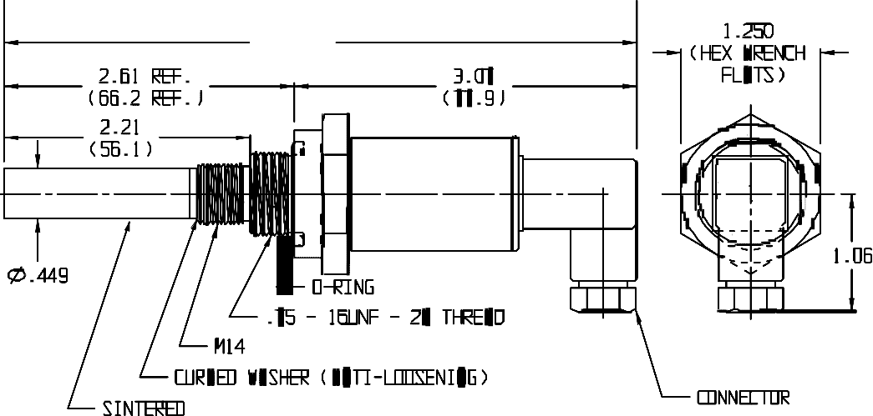Calibration method: . . . . . . . . . . Multipoint calibration table with temperature compensation over the full range

Dimensions:

Methods of using and interfacing the HDT Transmitter:

HDT Block Diagram

Factory Default Setup

1
Resetable
Fuse
100mA

28V

47Ω

3.3V

0.01μF Regulator

• Burst enabled Command 3
• Pin 3 mirrors HART output
3 μP
4/20mA
Bell 202 modem

in digital 0-3V levels.
• No polling address assigned
10K
0.01μF

2 Sensor

Housing GND Shield

Standard hookup
Monitor current (4/20mA) across resistor R, and/or HART signal across pins 1&2. Choose V and R such that there is a minimum of 6V across pins 1&2 when the instrument draws 20mA, and no more than 28V when the instrument draws 4mA. For standard HART connections recommended 250<R<500 ohms.

R
+V

Gnd

1
3 HDT
2
G

Economy hookup
Monitor digital RS-232 TTL level.

+5V to 28V
0-3V serial; inverted RS232 format
HART protocol
Gnd

1
3 HDT
2
G

Factory preset alarm hookup
Monitor and/or drive relay from digital level alarm. Special order means that factory default settings must be modified, and alarm level must be chosen.

+5V to 28V
Factory-set dewpoint alarm level
0-3V, 5mA max
Gnd

1
3 HDT
2 (special order)
G

Bell 202 demodulator or
Caller ID chip
+5V to 28V Gnd

50 Ω

1
3 HDT
2
G

Multi-channel hookup
Multiple HDT transmitters are parallel connected through an interface box to the serial port of a PC. In this mode, each transmitter draws 4 mA regard- less of dewpoint.

Serial port interface box

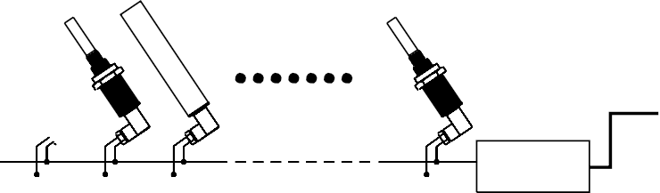Represented by:
Dr. Marino Müller AG
Process Control Instrumentation

w e l c o m e @ m u e l l e r a g . c h
G e w e r b e s t r a s s e 9 C H - 8 1 3 2 E g g S w i t z e r l a n d
Te l . + 4 1 4 4 9 8 6 2 9 2 9 F a x + 4 1 4 4 9 8 6 2 9 3 9

www.xentaur.com

Xentaur

Xentaur Corp., 3661 Horseblock Rd., Unit K, Medford, NY 11763 (631)345-3434 Fax: (631) 345-5349 email: xentaur@xentaur.com

